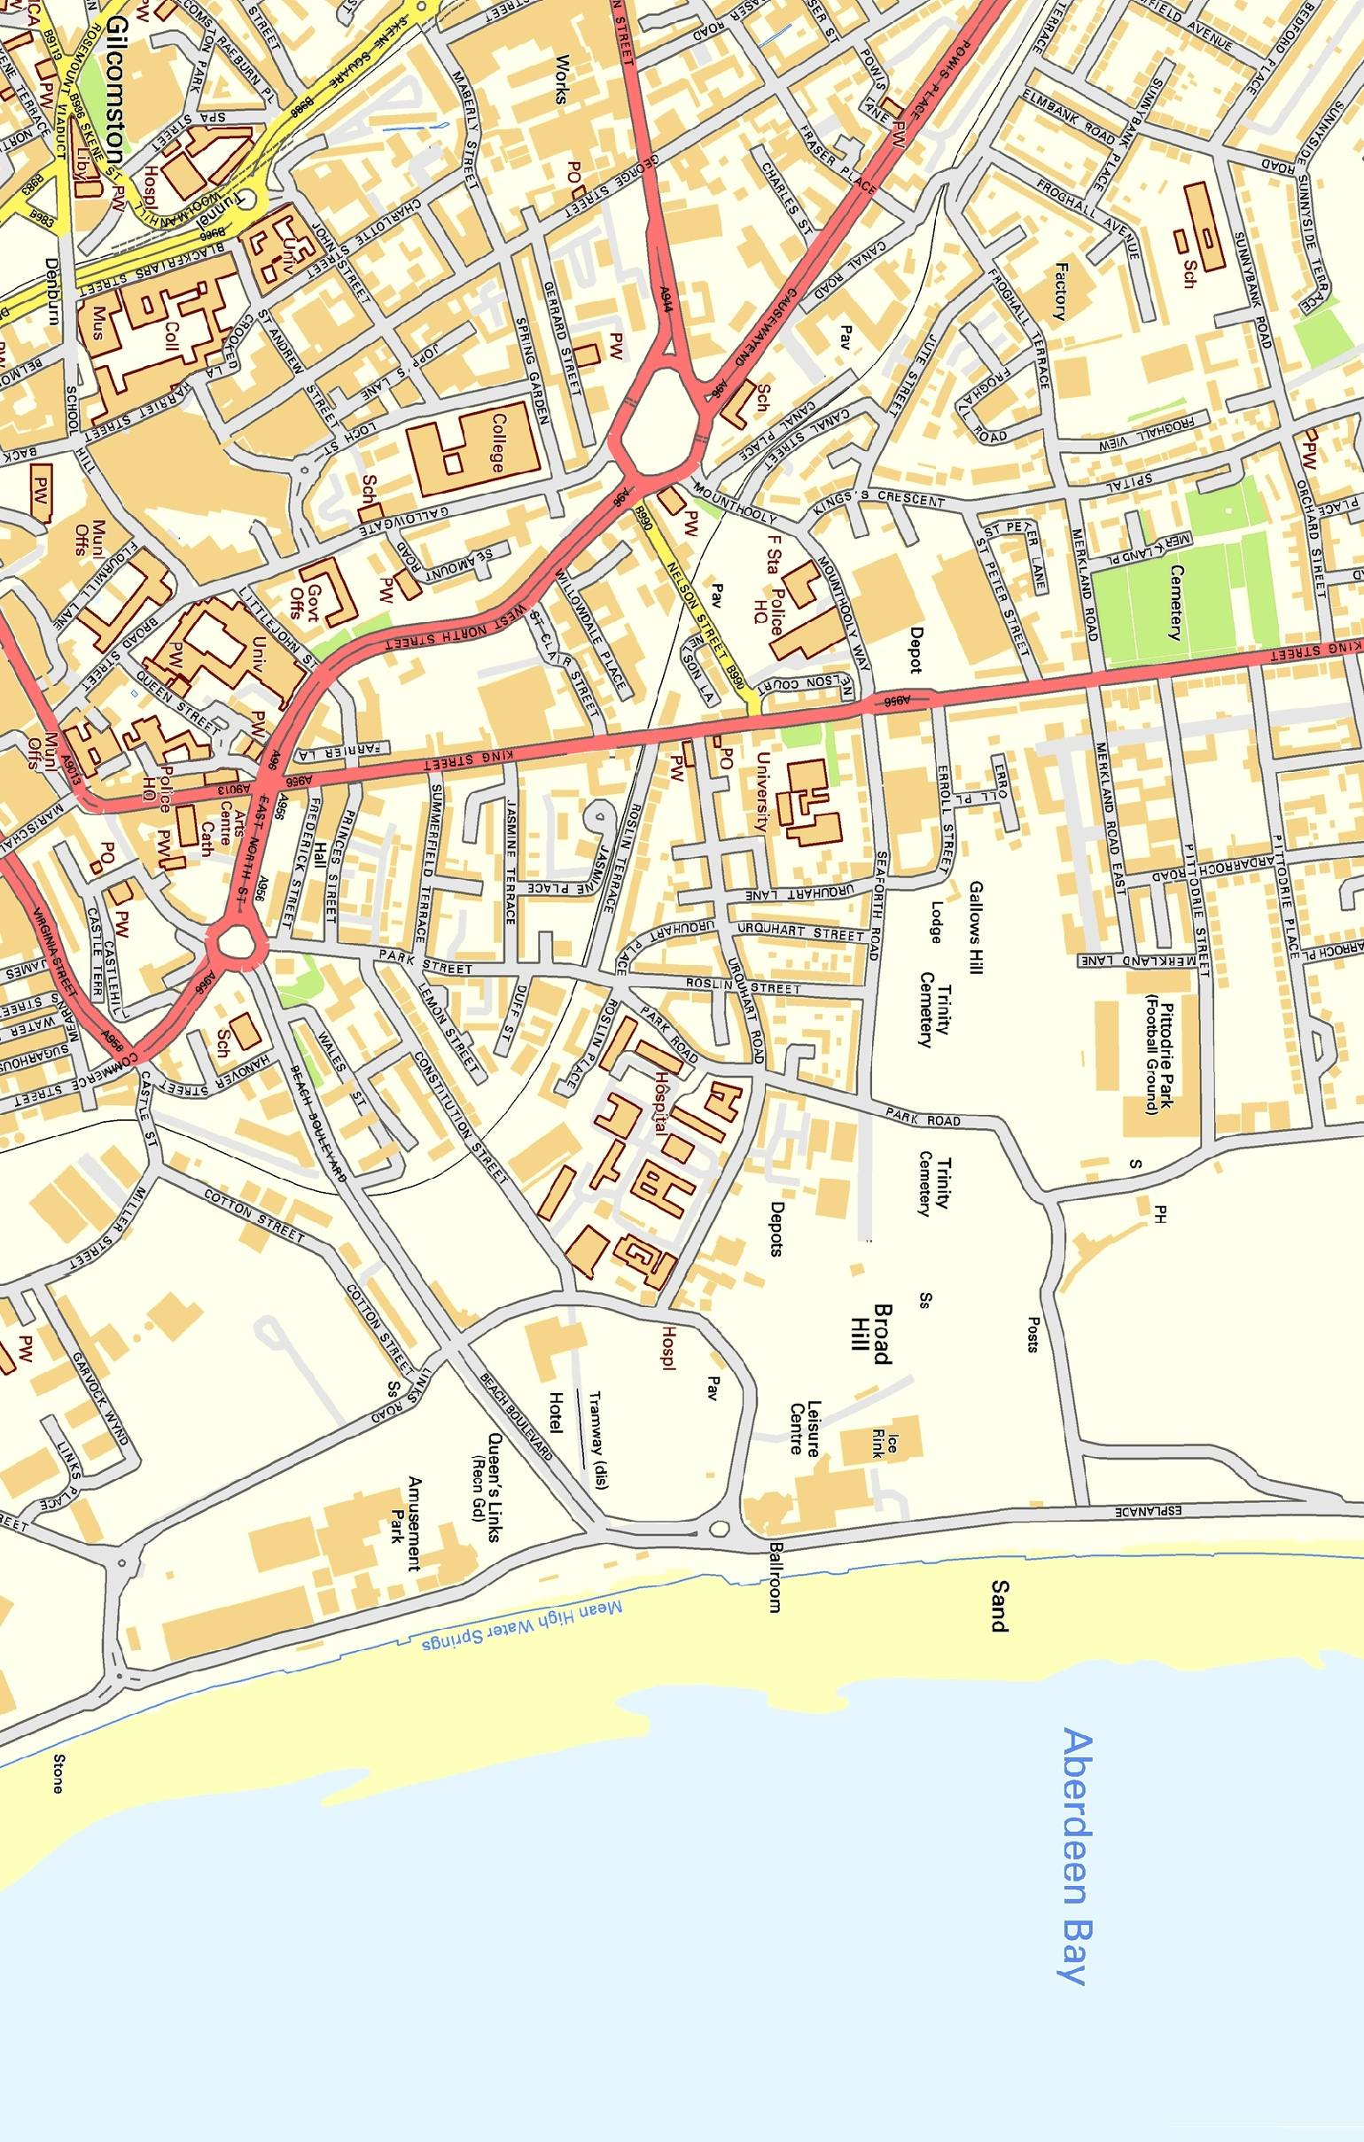
`

Welcome to

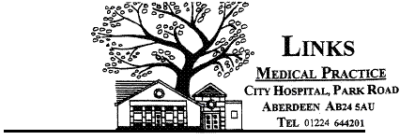

LINKS
MEDICAL PRACTICE

City Hospital, Park Road
Aberdeen, AB24 5AU

Tel: 0345 337 6340

Prescription Line: 01224 555149

www.linksmedicalpractice.co.uk
PRACTICE

June 2021

Contents
Opening Times
Partners
Salaried Doctors
Practice Manager
Practice Nurses
Community Staff
Maternity Care
Out of Hours

Practice Area/Surgery Access
Registering as a patient
Appointments
Home Visits
Speaking to a GP by telephone
Test Results
Sick lines
Repeat Prescriptions
Enquiries
Emergencies

Preference of Practitioner
Services available from the Practice
Foreign Travel
Minor Surgery
Screening Services
Childhood Immunisations
Lifestyle
Non-NHS Work
Patient Rights & Responsibilities
Protection & Use of Patient Information
Sharing Patient Information
Freedom of Information Act
Statutory Information
Complaints
How can you help us avoid problems?
Zero Tolerance Policy
Practice Accreditation Award
Zero Tolerance Policy

Z
ZERO TOLERANCE
The practice considers aggressive behaviour to be any personal, abusive and/or aggressive comments, cursing and/or swearing, physical contact and/or aggressive gestures.

The practice will request the removal of any patient from the practice list who is aggressive or abusive towards a doctor, member of staff, other patient, or who damages property. All instances of actual physical abuse on any doctor or member of staff, by a patient or their relatives will be reported to the police as an assault.

Training/Education

Medical Students – the practice has been involved in the teaching of medical students from the University of Aberdeen for many years. This means that a Medical Student may be present with the doctor during your consultation. If you wish to be seen on your own then please speak to the receptionist or doctor and this will arranged.

Foundation Year 2 (Junior Doctors) – the practice is involved in the training of junior doctors, who shall consult under supervision with patients during their 4 month attachment.

GP Specialty Trainees – the practice is involved in the training of GP trainees who will consult with patients under supervision during their time in the practice.

Opening Times
Please ask at reception for details of our early morning surgeries starting at 7am

Monday to Friday
8.00am – 6.00pm

Doctors

Dr Peter Watson (Partner)
Dr Louise Elliot (Partner)
Dr Daisy Cole (Partner)
Dr Gairn Davidson (Partner)
Dr Fiona Lopez (Partner)
Dr VuiYung Chieng (Partner)

Dr Rukayat Adenusi (Salaried GP)
Dr Ammara Sohail (Salaried GP)
Dr Mandeep Purba (Salaried GP)

Practice Manager

James O’Connor is the practice manager and is responsible for the administration and daily running of this busy practice. He is happy to hear any comments or suggestions about the services provided. He is responsible for our secretarial and administration team.

Practice Nurses

Faye Carbis Advanced Nurse Practitioner
Sister Kirsty Minett RGN
Sister Linda Warrander RGN
Sister Hilary Yule RGN
Sister Fiona Milne RGN
Laura Rojales Phlebotomist

Sr.Kirsty Minett heads our highly qualified nursing team. The practice policy is to encourage a healthy lifestyle, and our nurses run many of the screening programs which can help to prevent ill health. If you are invited to attend for such tests, please try to attend, as this can prevent complications in later life. The Practice Nurses can be contacted on 0345 337 6340.

Community Staff

Jackie Allan, Health Visitor
Penny Bruce Health Visitor
Karen Robertson, District Nursing Sister
Flora Doig, Community Nurse
Alison Nicol, Clerical Assistant

- District Nurses provide care for those discharged from hospital and those who require home care. Their multifunctional role includes health promotion, teaching, rehabilitation and palliative care. In consultation with the doctors they can also refer patients to other community services such as physiotherapy and chiropody if required.

The Nursing Team can be contacted on 01224 611077, Monday to Friday 8.00am – 4.00pm. There is an answer machine service so please leave your NAME and TELEPHONE NUMBER and one of the district nurses will contact you when she returns to the office.

Complaining on behalf of someone
If you are complaining on behalf of someone else, please be aware that this Practice is bound by strict rules of medical confidentiality and we cannot divulge a patient's medical history unless we have their permission to do so. If you are complaining on behalf of someone else, we have to know that you have permission to do so. A note signed by the person concerned will be needed, unless they are incapable (because of illness) of providing this. A form for this purpose is available at the practice upon request.

Complaining to NHS Grampian
We hope that if you have a problem you will make use of our complaints procedure. We believe this will give us the best chance of putting right whatever has gone wrong. But this does not affect your right to approach NHS Grampian if you feel that you cannot raise your complaint with us or you are dissatisfied with the results of our investigation. You should contact:
NHS Grampian Feedback service
Summerfield House
2 Eday Road
Aberdeen AB15 6RE
0345 337 6338
Email;-nhsgrampian.feedback@nhs.net
How can you help us avoid problems?

The majority of problems arising between the primary health care team and patients are ones of communication. You can help us avoid these in a number of ways.
- If you feel unhappy about anything please say so at the time. We will not take offence and will be happy to try and put matters right immediately.
- If you are unsure about any information given please ask for it to be repeated or written down.
- If you feel that a member of staff has not dealt with your problems adequately please ask to speak to the Practice Manager.
- Be prepared to give some clinical details if asking for an urgent appointment or call. The receptionist will be able to help you better if they understand your situation.
- If you have worries about clinical problems please ask to speak to a doctor.
Please help us to help you
Statutory Information

Here we will provide you with all of the statutory information required by the practice. Should you require any further information please do not hesitate to contact our Practice Manager.

All the Doctors and Staff in the Practice hope that we are offering an effective and efficient service. However, in view of the complexity of problems we deal with, we cannot guarantee that everything will always be perfect.
We hope that most problems can be sorted out easily and quickly, often at the time they arise and with the person concerned. Should this not happen and you wish to make a complaint or concern please contact the Practice Manager or in their absence the Office Manager who will assist you further. They will also provide you with a copy of NHS Scotland Complaints Handling Procedure leaflet which gives details of our Complaints Procedure.



- Health Visitors work within the Getting It Right For Every Child practice model (GIRFEC). They visit parents with children under 5 years within the family home, hold Well Child, Child Development and Immunisation Clinics.

The Health Visitors can be contacted on 01224 611088, Monday to Friday. There is an answer machine service so if they are unavailable leave a message and they will get back to you. Out of hours call NHS 24.

Maternity Care

We offer shared care with the staff of Aberdeen Maternity Hospital. Midwife Nicola Davis RGN M, runs weekly antenatal and postnatal clinics.

Out of Hours

Between 6pm and 8am Monday to Friday, and 6pm Friday to 8am Monday, the surgery is closed. In order to obtain medical advice at these times contact:

Out of Hours Service: NHS 24 on 111
www.nhs24.com

A receptionist in the emergency call centre will answer your call. Please note that out of hours cover is not a "walk-in service". You must call NHS 24 for advice first.

Practice Area / Surgery Access

Our well-established Practice serves approx 8500 patients, covering a wide area throughout the city as well as surrounding areas.

Access to the surgery is within the City Hospital Site and is fully accessible to disabled patients and has dedicated car parking space.

Registering as a Patient

You will be asked to complete a registration form for each person registering with the Practice. In addition, all patients will be asked to complete a new patient questionnaire, allowing us to provide medical care in the interim period, while your medical records are transferred from your old practice to this one. You will also need to provide us with 2 forms of ID (please ask at reception for further details)

Appointments

Appointments can be made by telephone (dial 0345 337 6340 then press 2) in person during surgery hours, Patients are seen by appointment only and are for 10 minutes to allow time to discuss your problem. Please make a separate appointment for each patient. Individual doctors consult at different times each week on a rota basis. Please check with receptionists for details. The receptionist can also take a message for your doctor, who will phone you back if necessary. The “duty doctor” will deal with urgent matters. Remember the doctor may be busy with another patient.
If you cannot keep your appointment please let us know.
Triage System

The practice has recently introduced a triage system. To ensure that your request for an appointment / telephone call / home visit is directed to the correct healthcare professional, and to ensure there is adequate time to deal with your problem, reception staff will ask for a brief description of your problem. This will also allow emergencies to be dealt with promptly. Reception staff abide by the code of confidentiality. Please remember that reception staff are not medically trained so cannot give medical advice.

.
Sharing of Patient Information

From time to time it is necessary for us to share your medical details with other Health Care professionals. E.g. – Hospital consultants, Health visitors, Out Of Hours Doctors and our Integrated Social Care Team. This will only be done with your approval. If we have to pass on details to Insurance companies’ etc we will only do this with your written permission.
Freedom of Information Act

You are entitled to access certain information about the surgery, its staff, and activities. You are also entitled to access clinical and personal information held about you.
All information at Links Medical Practice is held, retained and destroyed in accordance with NHS Scotland guidelines.
For further information http://www.gov.scot/About/Information/FOI

Protection & Use of Patient Information

Data Protection Act 1998
GPs place paramount importance on service and your expectations to provide you with optimum health care and treatment. To this end, we need accurate personal information from you, which we review regularly for changes in circumstances. To ensure that you receive the best possible care and that we can all work together for your benefit, there may be occasions when we need to share some information about you with others.

You have a right to obtain information we hold about you by making a Subject Access Request (SAR) Access can be arranged by contacting the practice manager.

General Data Protection Regulations (GDPR)

How we use your medical records - Important information for patients

- This practice handles medical records in-line with laws on data protection and confidentiality.

- We share medical records with those who are involved in providing you with care and treatment.

- We may also share medical records for medical research and to check the quality of care provided to you.

- We share information when the law requires us to do.

- For more information ask at reception for a leaflet OR visit our website www.linksmedicalpractice.co.uk

In addition please note that:

- Separate appointments should be made if more than one person needs to be seen.

- An adult should accompany children under the age of 14.

- If you think your problem will require more time than 10 minutes, please tell the receptionist and arrangements may be made for you to get a longer appointment.

- If you are unable to keep an appointment, phone and let us know as soon as possible so that the appointment can be reallocated. You can also cancel your appointments online.
Repeatedly missing appointments may mean that you may be asked to leave the practice list.

NB: Appointment schedules are liable to change at short notice depending on doctor availability.
Home Visits

Home visit requests should be requested before 10am unless it is an emergency as this allows for the allocation of visits and efficient use of time for visiting clinicians.
Home visits are discretionary. We wish to provide safe, high quality care for all of our registered patients. It is important to assess a patient in the safest environment; this is rarely a patient’s home and the doctor will also not have full access to a patient’s records or to a chaperone in a patient’s own home. It is also inefficient as in the time it takes one practitioner to perform a visit, many more patients could be seen face-face in the surgery.

Only patients who are terminally ill or housebound will normally be granted a home visit. All other patients are generally expected to attend the surgery.

The general rule is that if a patient is fit enough to visit an optician, dentist, friend, relative, attend a hospital appointments, do their own shopping or visit the hairdresser, they can come to the surgery.

Telephone
A patient may not be well enough to travel by bus or walk but travel by car can be arranged via friend, relatives or taxi firms. It is not the doctor’s duty to arrange such transport. Having no transport is not a reason for a home visit request.

All home visit requests will be triaged by the clinical team. Some symptoms can be self-managed and patients may not require to be seen by a clinician. Some symptoms can be dealt with by other professionals who are more appropriate for your needs e.g. pharmacist or district nurse.

Please telephone before 10:00am with house call requests

The visiting doctor may not always be your usual doctor


Speaking to a GP by telephone

Doctors are available each day they are consulting to speak to patients regarding results or general advice. Please try to stay with the same doctor for any ongoing problems.

Test Results

For reasons of confidentiality we cannot give results at our reception desk. Please telephone between 11am – 3pm (dial 0345 337 6340 then press 3). We will only give results to the patient, unless we have prior permission to speak to somebody else. Please allow 7 working days before phoning for your result

Medical Certificate

You are responsible for self-certification for the first seven days of any illness (including Sundays) These forms are available on line www.gov.uk
For other certificates, our doctors are legally obliged to speak to the patient before they sign one.

Repeat Prescriptions

If you are taking medication on a repeat basis please order in plenty of time, and allow us four working days from order until you pick up the prescription. They can be ordered in the following ways.

- By Post: The right hand side of your last prescription gives details of your current medication. Tick the items you require and post the slip to us. If you enclose a stamped address envelope we will post your new prescription back to you. Otherwise, you may collect it three working days after Receipt of the request.

Non-NHS Work
Most of the services provided within the practice are free under the National Health Service. However, this does not cover examinations for special purposes (e.g. fitness to drive or to undertake certain sports); the completion of forms such as holiday cancellations or sickness insurance claims; private medical insurance claim forms; or certain travel vaccinations. For all private requests please ask for cost and forms at reception.
Patient Rights & Responsibilities

You will be treated with respect and as a partner in your care. Being a partner means you have responsibilities too.

We will:
- Ensure our patients have 24-hour access to medical advice.
- Aim for you to have access to a suitably qualified medical professional within 48 hours of your initial contact during surgery hours, or in an urgent case, the same day.
- Work in partnership with you to achieve the best medical care possible.
- Involve you and listen to your opinions and views in all aspects of your medical care.
- The prevention of disease, illness and injury is a primary concern. The medical staff will advise and inform you of the steps you can take to promote good health and a healthy lifestyle.

We would respectfully ask that you:
- Let us know if you intend to cancel an appointment or are running late.
- Treat staff with courtesy and respect. Reception staff may have to ask some personal questions to assist us in providing you with the best service.
- Inform the practice staff of any alterations in your circumstances, such
as change of surname, address or telephone number. Please ensure that
we have your correct telephone number, even if it’s ex-directory.
- As patients, you are responsible for your own health and that of any dependants. It is important that you adhere to information and advice given to you by health professionals, and co-operate with the practice in endeavouring to keep you healthy.

Childhood Immunisations

The following are the recommended Routine Immunisations, which every child should have:

8 weeks 1st DTaP/IPV/Hib,Hep B(Diphtheria,Tetanus,acellularPertussis/
Inactivated Polio Haemophulus Influenzae B, Hepatitis B) and Pneumococcal rotavirus
Meningitis B
12 weeks 2nd DTaP/IPV/Hib, Hep B.. Rotavirus
16 weeks 3rd DTaP/IPV/Hib, Hep B, & Prevenar. Meningitis B
12-13 months Haemophulus Influenza B/ Meningitis C (Hib Men C)
MMR (Measles/Mumps/Rubella) & Prevenar. MeningitisB
4 years dTap/IPV (low dose Tetanus/acellular Pertussis/Inactivated
polio) and MMR

For under 5s your Health Visitor will advise you on the current UK Vaccination
Schedule.



- In Person: Leave your request in the box provided at reception. Use either the right-hand side of your last prescription or ask the receptionist for a request slip to complete. Our receptionists will be pleased to help you if you have any problems.

- By Telephone: The prescription request lines are open 24 hours a day. Telephone: 01224 555149. Please leave the following information on our answer machine:
- Name
- Address
- Date of Birth
- Contact telephone number
- Items required
- Where you will collect the prescription eg surgery or specify chemist
- On-Line Services – You can register to order your repeat prescriptions via Vision On-Line Service (please ask for details)
- Via your Local Pharmacy: Some local pharmacies provide an ordering and collection service. Further details are available at reception.
Enquiries

Please remember that our receptionists may have to ask questions to establish your identity; assess the best course of action for your problem; or obtain details to pass on to the doctor. Such questions are meant to help you and are not designed to be obstructive or intrusive. All staff are bound a duty of confidentiality for all patient information they are party to.
Emergencies

In life-threatening emergencies, such as severe bleeding, collapse, unconsciousness or severe chest pain, telephone "999" for an ambulance.

Services available from the Practice

Links Medical Practice has signed a contract with NHS Grampian to provide the following Services:

Essential Services
All GPs must provide essential services, that is, basic treatment of ill people.

Additional Services
Links Medical Practice also provides the following “additional services”:

- Child health surveillance, together with the Health Visiting team
- Contraceptive services including contraceptive advice, oral contraceptive pills, contraceptive injections and implant fitting, and IUCD (coil) insertion.
- Maternity services in the ante-natal and post-natal period, together with the midwives from the Aberdeen Maternity Hospital
- Routine immunisation of children, together with the Health Visiting team.
- Cervical smears
- Minor Surgery Clinics.

Minor Surgery

Various small operations under local anesthetic are undertaken at the surgery. This service has proved to be beneficial to our patients

Enhanced Services
Links Medical Practice also has a contract with NHS Grampian to provide the following “enhanced services”:

- Regular monitoring, by blood and urine tests, for patients on a range of drugs for arthritis.
- Regular monitoring, by blood tests for patients on warfarin.
- Annual comprehensive reviews for patients with heart disease
- Annual comprehensive review of Chronic Disease Management and Monitoring .
- Minor Injury Service
- Substance Misuse

Please note that not all of the doctors provide all of the services. This is a Practice Contract.

Foreign Travel

Our practice nurses will be pleased to advise you on the injections needed for travel to any part of the world, along with other relevant information such as precautions to take about drinking water and similar matters.
NB: not all vaccinations for foreign travel are available on NHS. Please note you need to organise travel appointments at least 6-8 week before you are due to go.

0345 Telephone Number
.

The 0345 service chosen by NHS Grampian utilises a networked based system that can offer callers a choice of options in order to route their call accurately and efficiently. The options, of this service, are controlled in the service provider’s network completely independently of the make, type or capabilities of the lines or equipment at the receiving location.

The cost of this service (using the NHSG 0345 number), to callers, is 3.36 pence per minute (ppm) during peak time, 1.85ppm evening and 085 ppm weekend which is exactly the same cost as making a local call. Calls are charged on a per second basis. The inclusion, or otherwise, of 0345 numbers in free callings plan is an issue that needs to be addressed with the various telecoms suppliers as each and every call provider has different ways of applying call charges. Non geographic numbers, call to mobile networks, and calls to other network providers’ numbers are an ongoing source of debate, within the telecoms industry, that NHS Grampian has no control over but understands the confusion and concern that the wide and varied pricing plans evoke.

The use of a low cost service is seen as advantageous to the vast majority of patients calling their health centre or GP practice.
NHS Grampian adopted the use of the 0345 service to provide an improved service for both patients and staff and I include below some of the benefits we see by utilising this service

- The use of a single 0345 number ensures that all callers can be re-routed, in real time, in the event of an emergency or disaster recovery situation
- Use of a network based call queuing system to handle call volumes
- Menu options to direct callers and filter and prioritise calls including effective call distribution or call control

- The entire system is controlled, by the receiving location, based on timing stored in the network
- Network messages can be used to inform callers of outbreaks or common problems
- Real time statistics show how many calls are received / unanswered. This allows analysis of the history of our non-geographic number to help implement improvements in the current service
- Patients no longer receive engaged tone and no longer have to constantly re-dial the surgery
- Pressure is absorbed by the telephone network allowing staff to handle calls more effectively
- Web and phoned based control of built in disaster recovery option should the surgery be unavailable
- A single point of contact, independent of constraints on local / national telephone network provide.

I hope this explains why it is important and sensible for NHS Grampian to utilise the 0345 service.

